PROGRESS REPORT 5:
NAME: Sanjaya C Bhat
SUBSYSTEM: Coding
DATE OF SUBMISSION: 11/4/2022
REPORTING PROGRESS FROM: 11/4/2022—16/4/2022

PROGRESS:
- Wrote and exucted the program to move the turtlesim bot forward, using keys and go to goal.
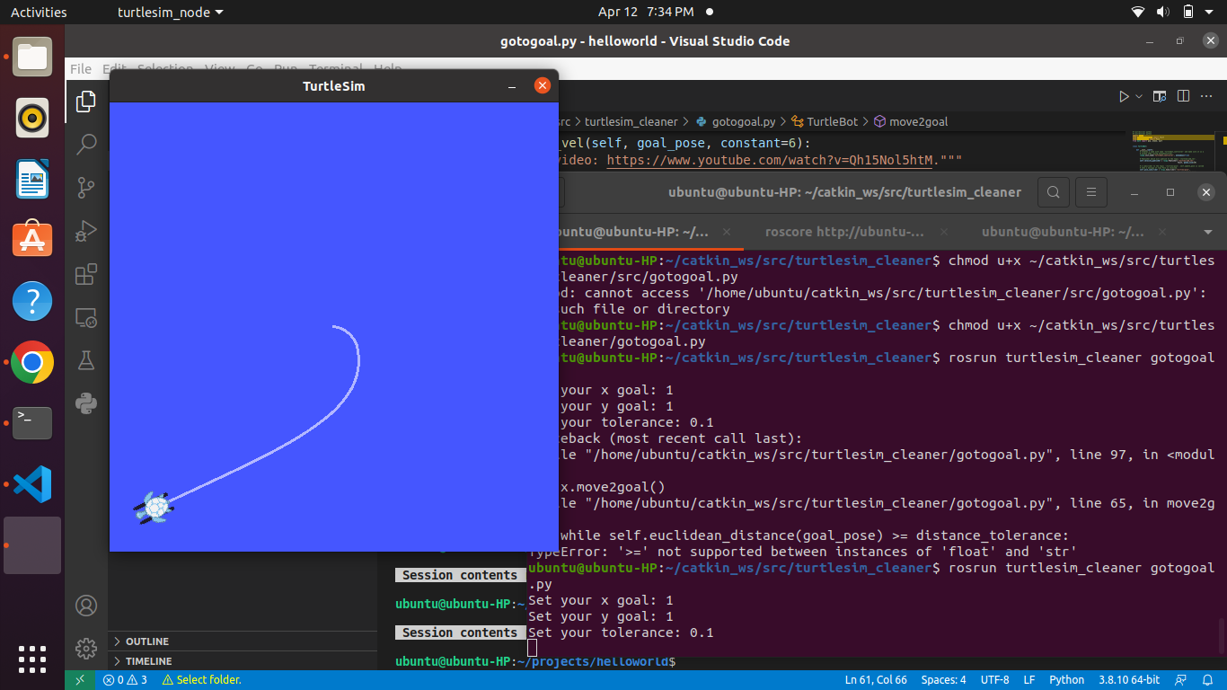

2 Wrote a publisher and subscriber using python and was able to send and recieve messages.
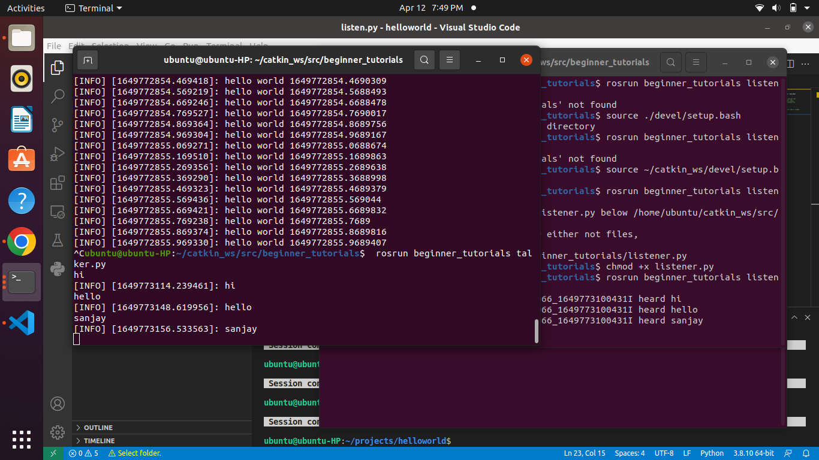
3. Installed gazebo environment and launched the turtlebot.

